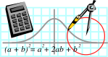  Rossmoyne SHS  Mathematics  Department | MATHEMATICS 3CD | Semester 1 2011  EXAMINATION

NAME:
TEACHER: Mr Birrell Ms Goh Mr Whyte
Mr White Mr Longley Mr Jones

Section One:
Calculator-free

Time allowed for this section
Reading time before commencing work: 5 minutes
Working time for this section: 50 minutes

Material required/recommended for this section

To be provided by the supervisor
This Question/Answer Booklet
Formula Sheet

To be provided by the candidate
Standard items: pens, pencils, pencil sharpener, eraser, correction fluid, ruler, highlighters

Special items: nil

Important note to candidates
No other items may be used in this section of the examination. It is your responsibility to ensure that you do not have any unauthorised notes or other items of a non-personal nature in the examination room. If you have any unauthorised material with you, hand it to the supervisor before reading any further.

Structure of this paper

Section | Number of questions available | Number of questions to be answered | Working time (minutes) | Marks available
Section One:  Calculator-free | 7 | 7 | 50 | 40

Instructions to candidates

1. Write your answers in the spaces provided in this Question/Answer Booklet. Spare pages are included at the end of this booklet. They can be used for planning your responses and/or as additional space if required to continue an answer.
  - Planning: If you use the spare pages for planning, indicate this clearly at the top of the page.
  - Continuing an answer: If you need to use the space to continue an answer, indicate in the original answer space where the answer is continued, i.e. give the page number. Fill in the number of the question(s) that you are continuing to answer at the top of the page.

2. Show all your working clearly. Your working should be in sufficient detail to allow your answers to be checked readily and for marks to be awarded for reasoning. Incorrect answers given without supporting reasoning cannot be allocated any marks. For any question or part question worth more than two marks, valid working or justification is required to receive full marks. If you repeat an answer to any question, ensure that you cancel the answer you do not wish to have marked.

3. It is recommended that you do not use pencil except in diagrams.

QUESTION | MARKS AVAILABLE | STUDENT MARK
1 | 8
2 | 8
3 | 5
4 | 6
5 | 4
6 | 5
7 | 4
TOTAL | 40

QUESTION 1. ( 8 marks)

(a) Differentiate the following. You do not need to simplify your answer.
y = x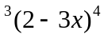

(b) Differentiate the following , leaving your answer in a factorised form.
y = 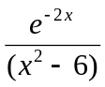

(c) Hence, clearly demonstrate that the function y = has exactly two stationary
points. Find the coordinates of these points giving your answers as exact values.

(NOTE: you should not attempt to find the nature of each stationary point.)

QUESTION 2. ( 8 marks)

(a) Determine 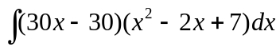

(b) Evaluate 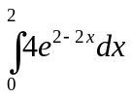

(c) Find A in terms of t, given that 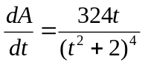 and A =5 when t = 1 .

QUESTION 3. (5 marks)

The probability function for a discrete random variable X is given by,
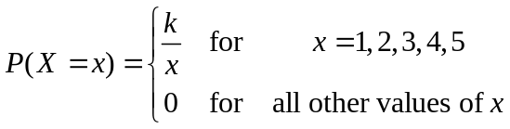
(a) Complete the following probability distribution for X, giving the probabilities as fractions.
( i.e. k should be evaluated)

x | 1 | 2 | 3 | 4 | 5
P(X=x)

(b) Determine the mean , or expected value of x.

QUESTION 4. (6 marks)

The time, in minutes, to complete a survey is found to be between 3 and 11 minutes. If we use a
uniform continuous random variable X to model the situation, the time taken to complete the survey.

(a) Show the probability density function of X graphically.

Hence find.
(b) P( X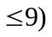

(c) P(X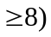

(d) P(X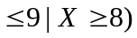

QUESTION 5. (4 marks)

Two events X and Y are such that P(X) = 0.7 and P( X Y ) =0.8

(a) Calculate the P(Y) if X and Y are mutually exclusive.

(b) Calculate the P(Y) if X and Y are independent events.

QUESTION 6. (5 marks )
Solve the following system of equations 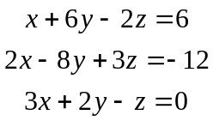

QUESTION 7. ( 4 marks)

An on line company specializing in kitchen appliances decides to give a free cooking book with every
item purchased during the month of May. The cook books are randomly selected by the computer at
the time of purchase .

(a) If there are only 4 different cook books available as free gifts. Find the probability of getting
a complete set ( of cook books) by purchasing exactly 4 items.

(b) If there are "p" different cook books, find the probability of getting a complete set by ordering
"p" items.

